**20 Epochs where trained**

| **Model** | **Before Training** | **After Training** |
| --- | --- | --- |
| VGG16 | 13% | 99% |
| ResNet50 | 12% | 99% |
| MobileNetV2 | 20% | 90% |

**Before Train Confusion Matrix and F1 Score:**

VGG16:

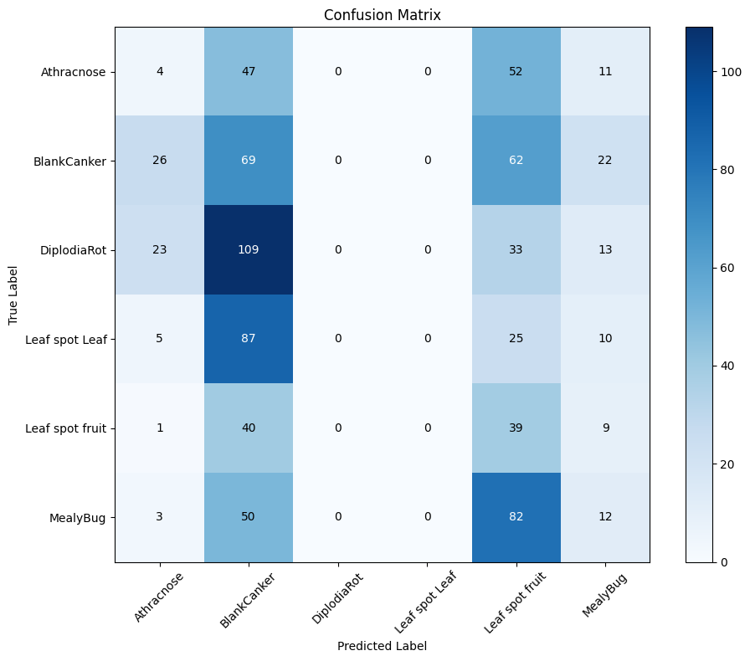

ResNet50:

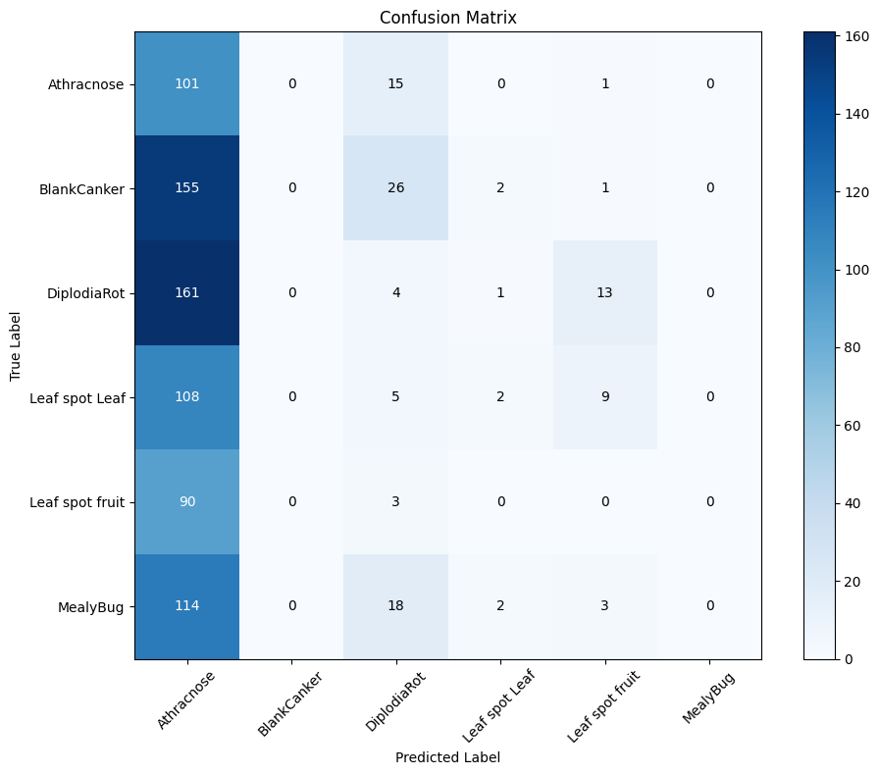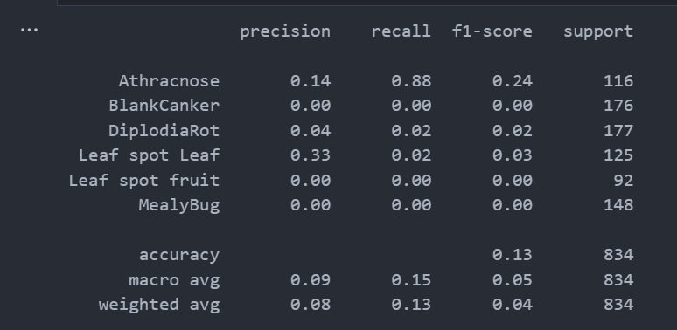

MobileNetV2:

**After Train Confusion Matrix and F1 Score:**

VGG16:

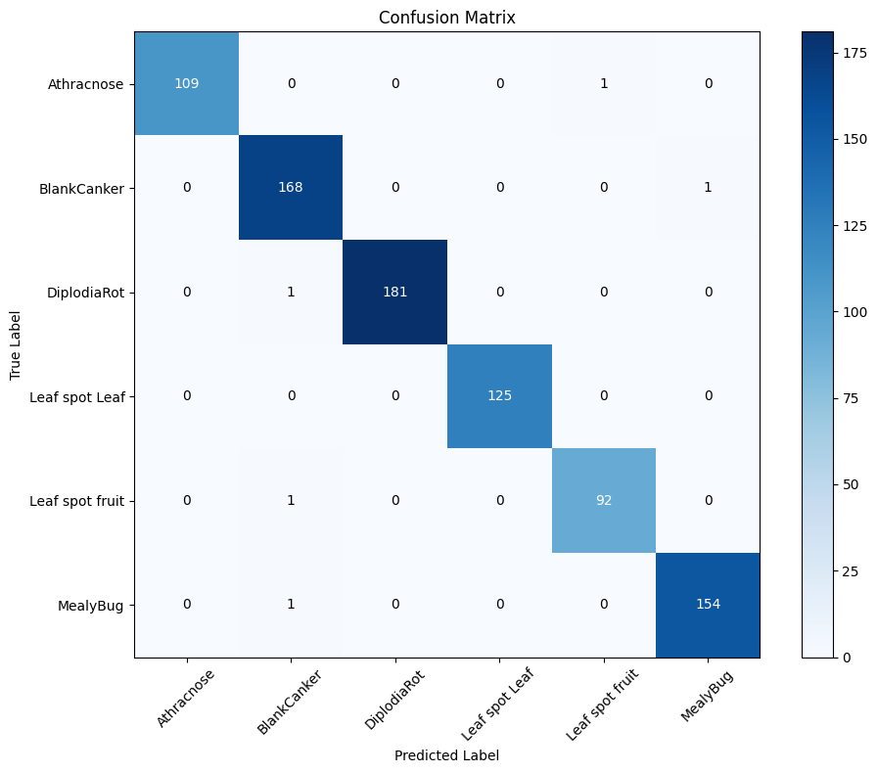

ResNet50:

MobileNetV2:

